Melissa Yee

100729644 | March 28, 2020

AIDI 2004 – AI in Enterprise Systems

Assignment #1 - Flask

# Create Database

For the Flask app, I decided to use an SQLite database as it is very lightweight and can be easily integrated into the application.

1. Created database.py file which creates database with the students table
2. Confirmed that database file was created properly

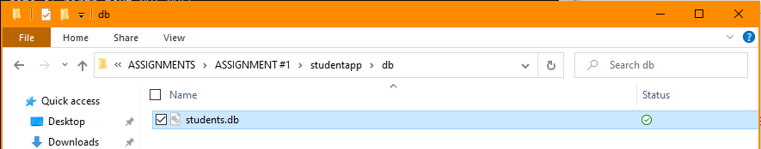

1. Confirmed that table was created in database with proper schema  
   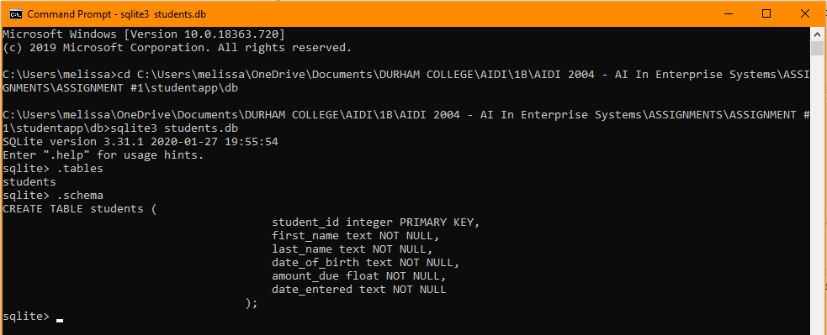

# Create Basic Flask App

A flask app was created that will be able to perform the CRUD operations to the created students table. The home page of the application is shown below along with the project files created in PyCharm.

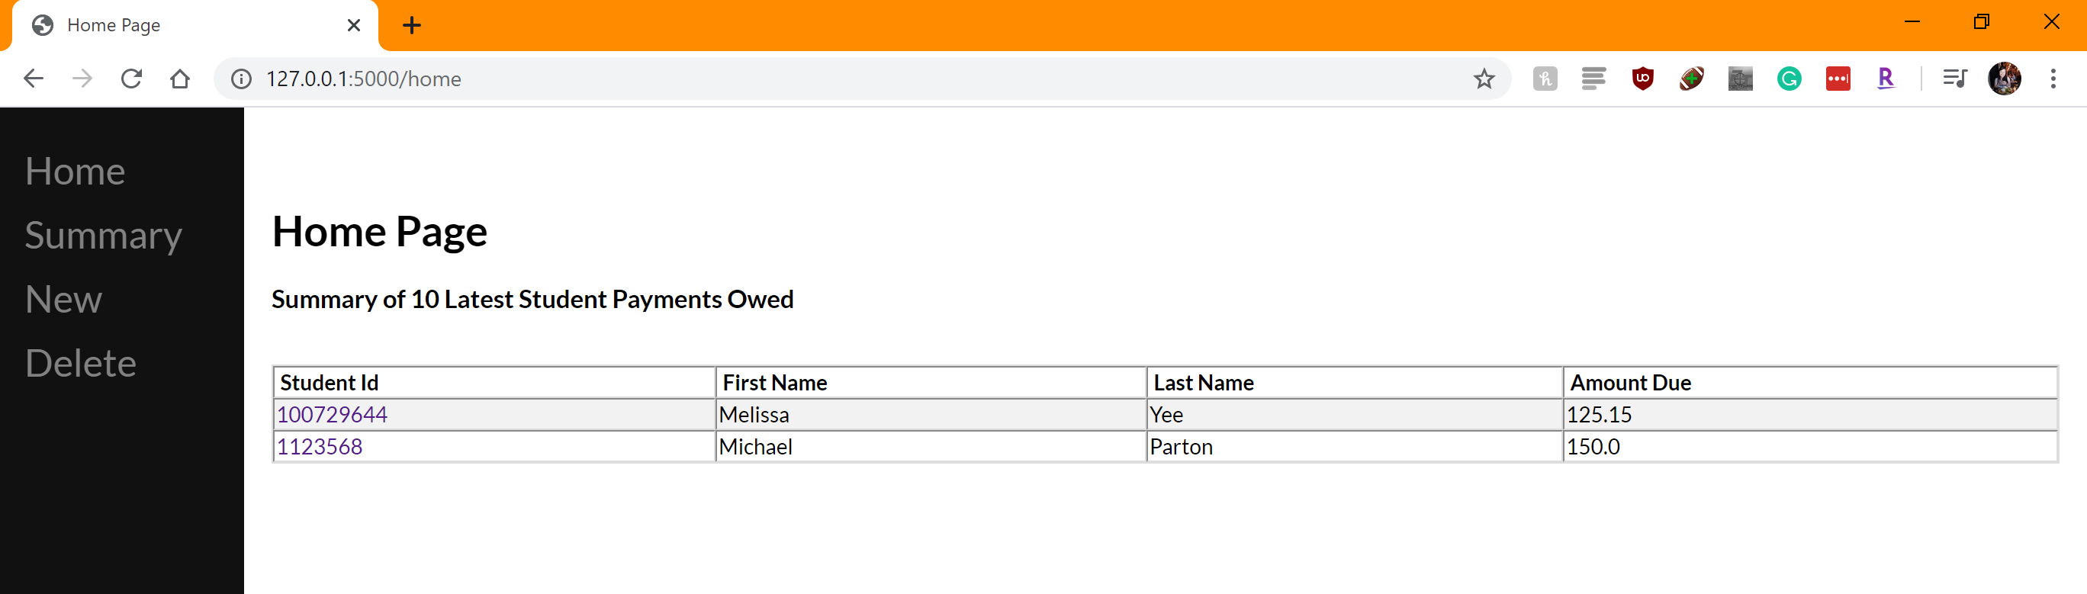

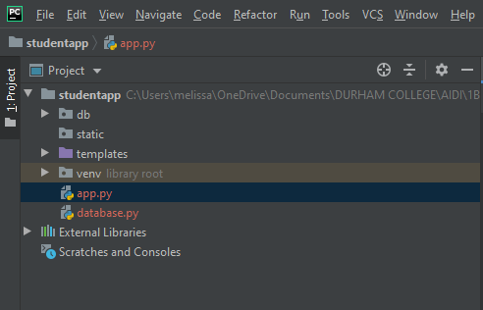

# Create

1. The New page can be used to create new students and insert them into the database  
   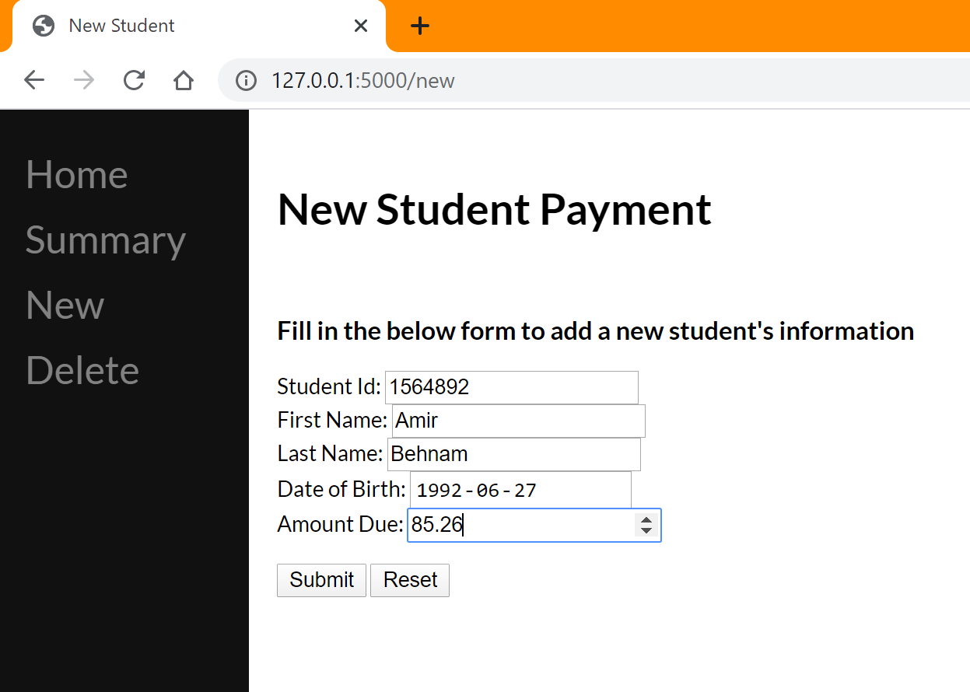

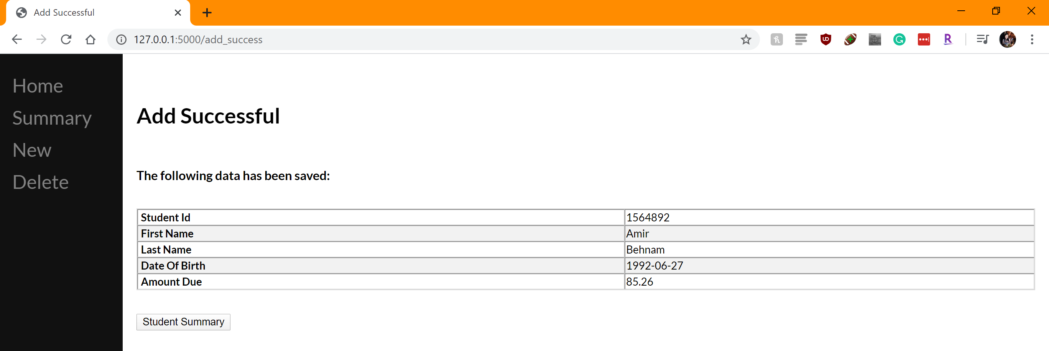

1. Once submitted, we can see that the entry has been updated on the summary page  
   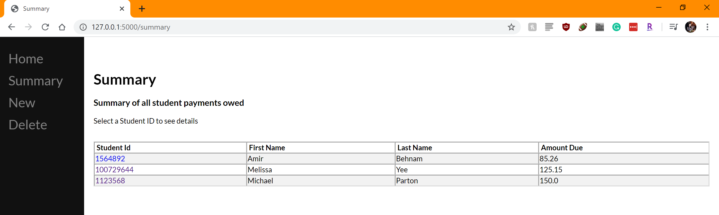  
   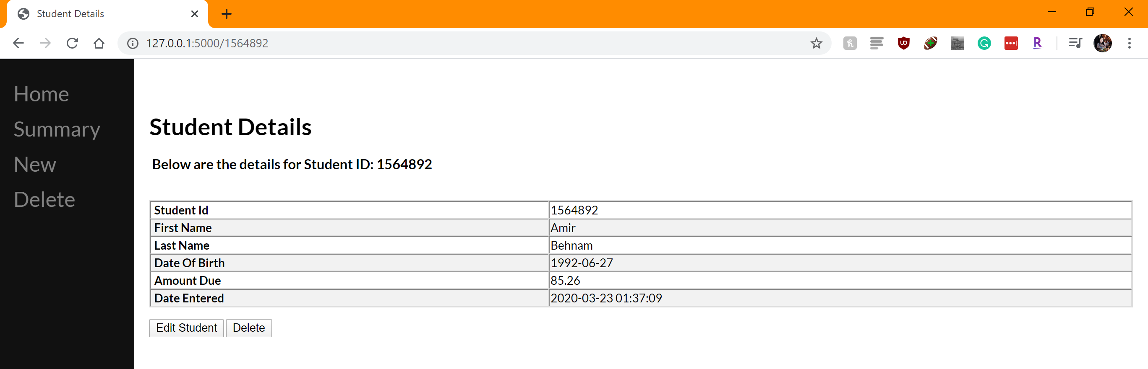
2. We can see the inserted row in the database as well  
   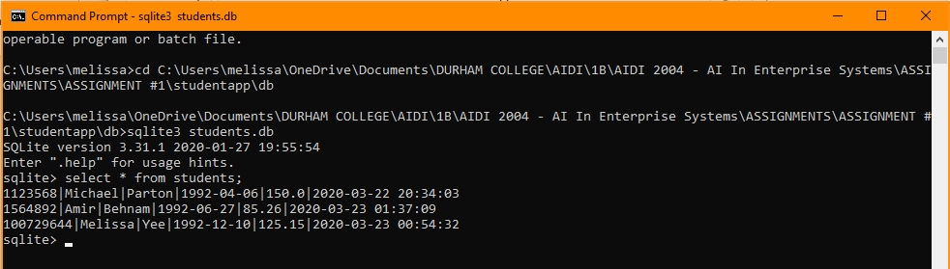

# Read

1. The Summary page shows us all the records available in the database



1. We can also read individual students by clicking into the student detail page  
   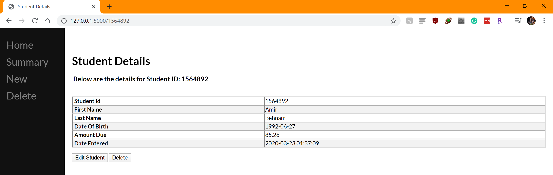

# Update

1. The Edit Student button in the Student Details page allows us to edit the details and update the database. I’ve changed the amount owed to 1500.00  
   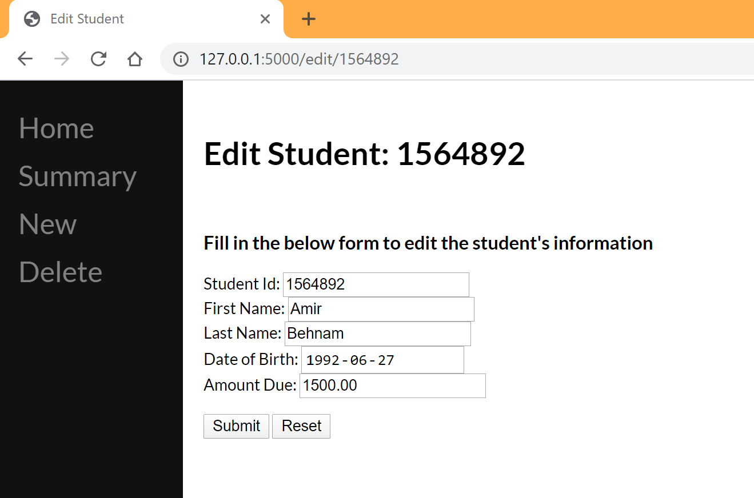

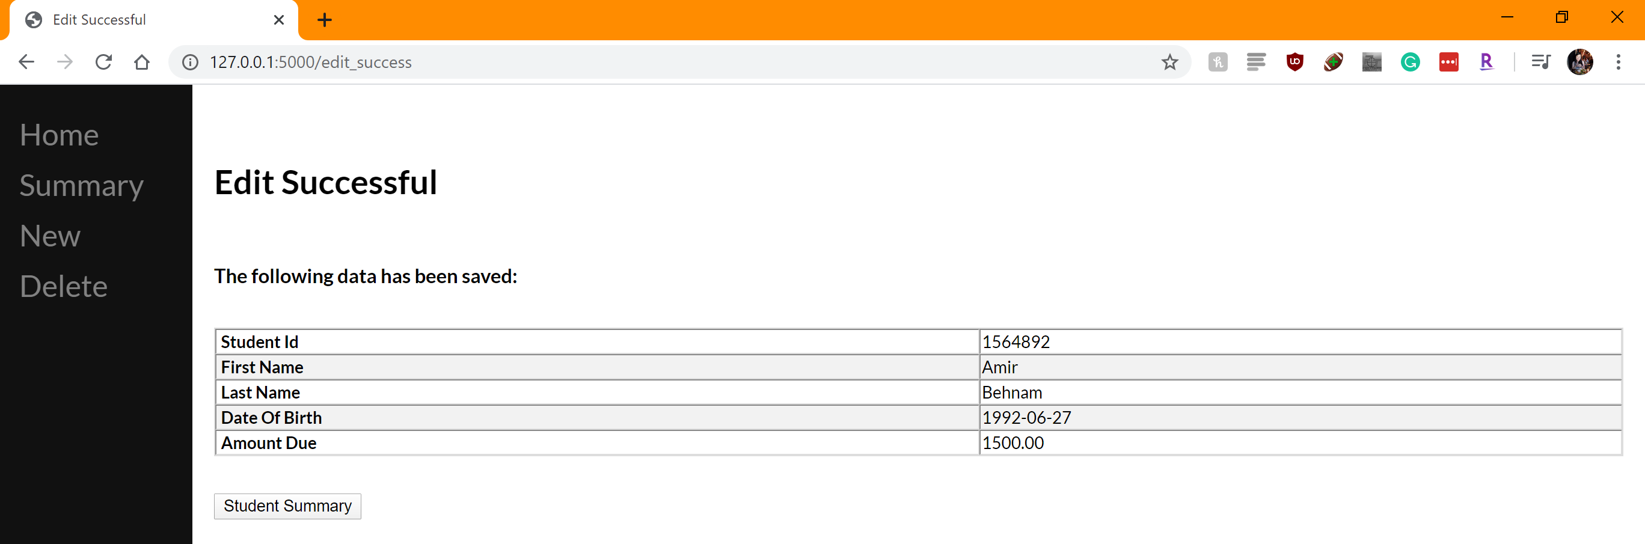

1. The changes are then shown in the summary

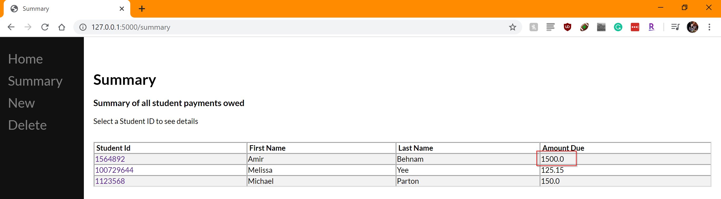

1. The changes are also updated in the database

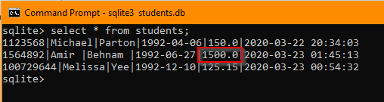

# Delete

1. The Delete page can be used to delete records in the database. You can select one or more records to be deleted  
   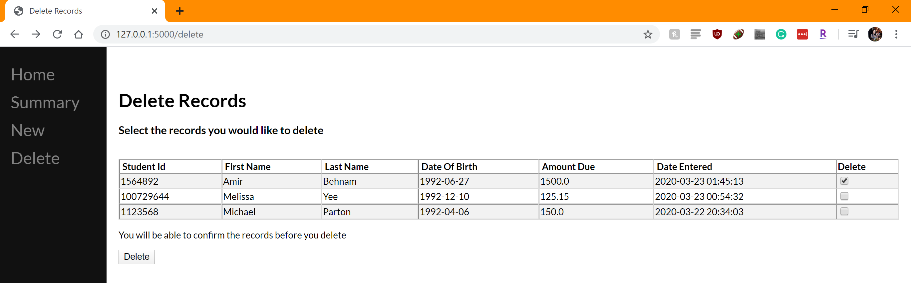  
   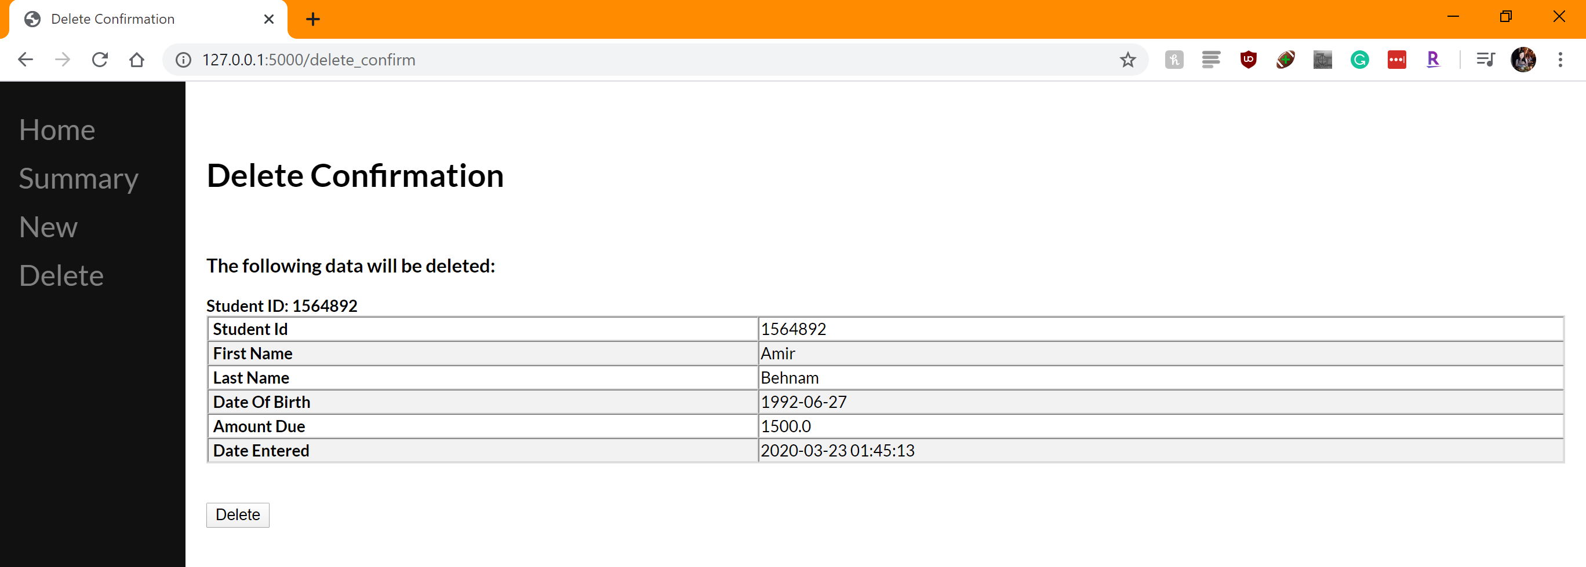  
   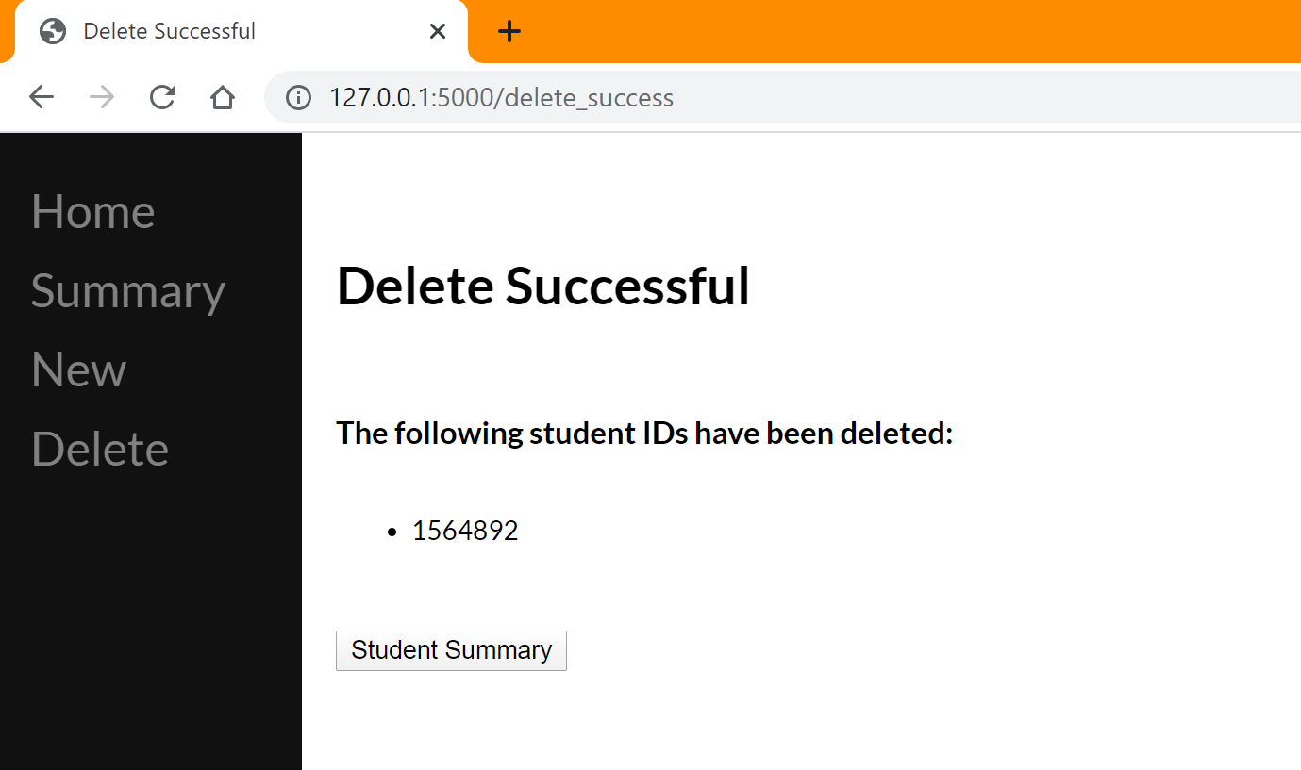
2. The record no longer appears in the Student Summary  
   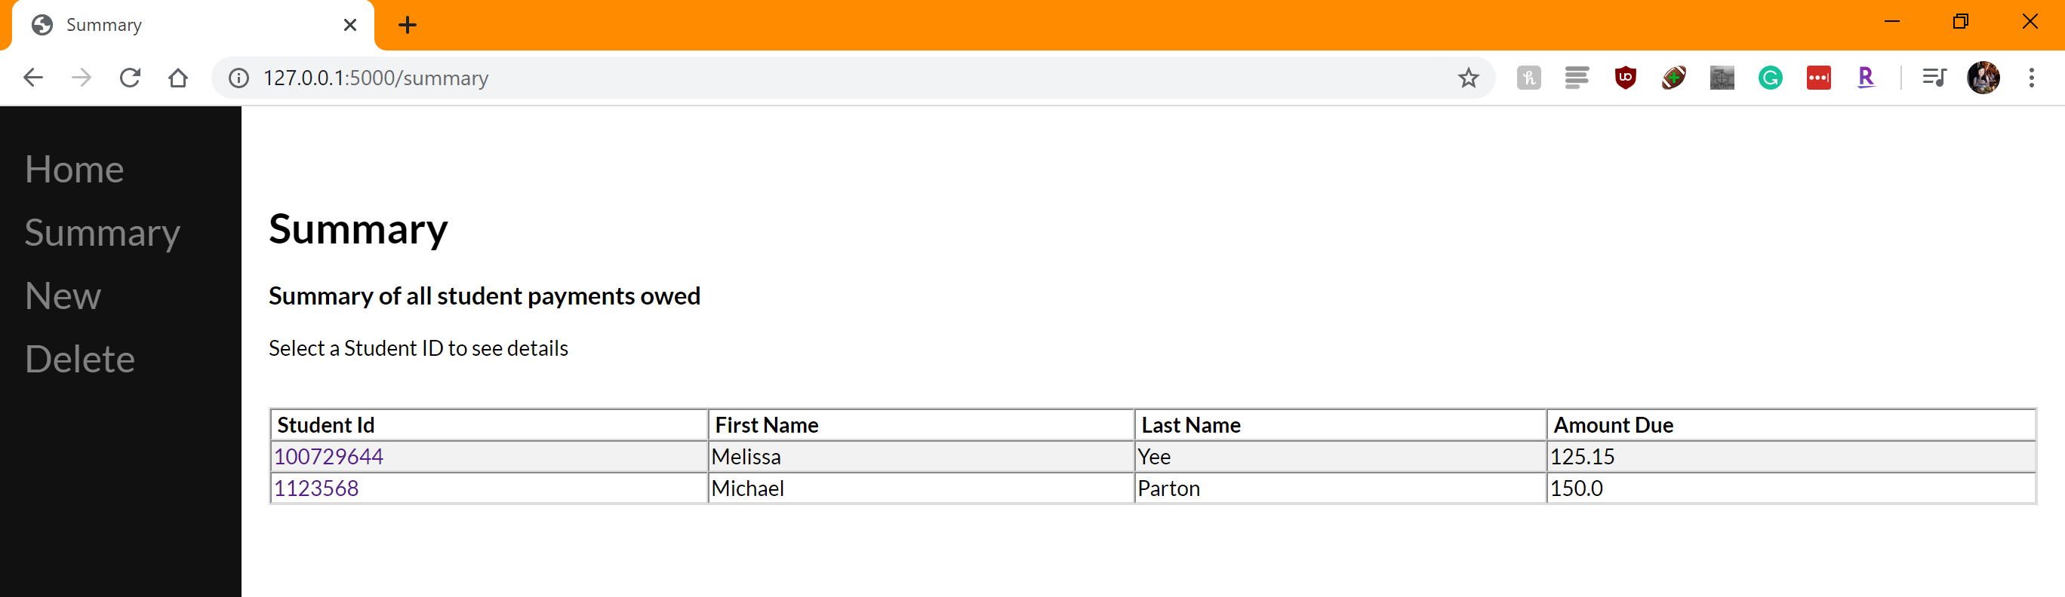
3. We can confirm that it has been deleted in the database  
   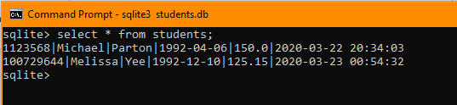

# Show All Records

1. The summary page allows us to see all records currently in the database, although it doesn’t show all the columns  
   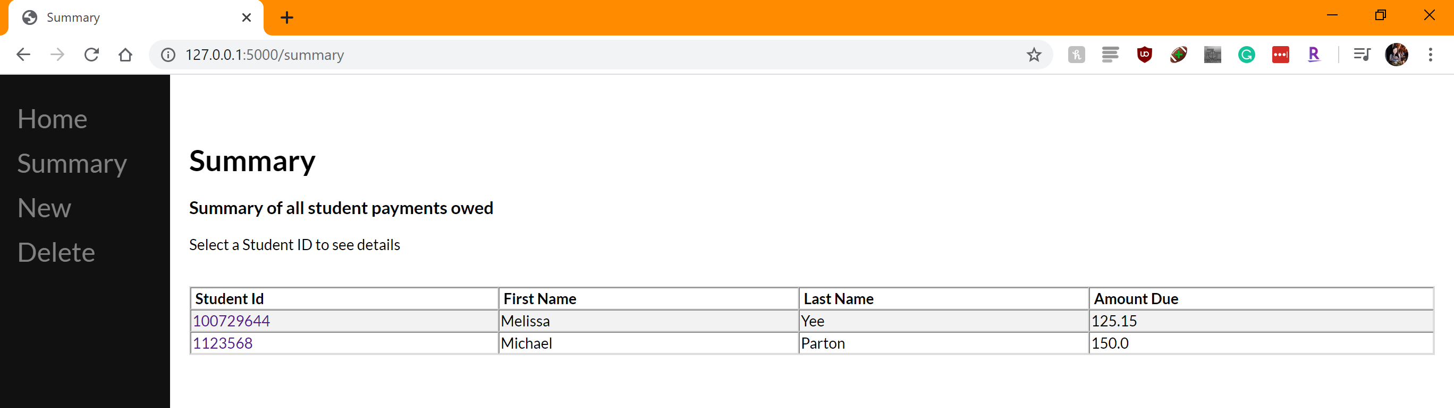
2. The Delete page shows all rows and columns  
   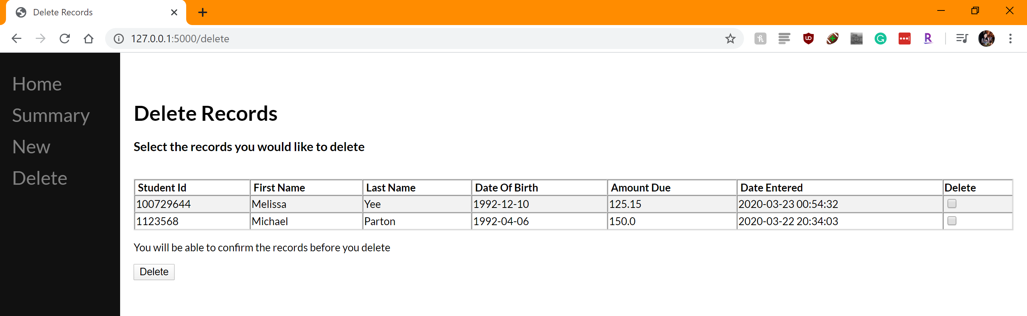

# Git Repository

The GitHub repository for this project can be found at: <https://github.com/melissayee/AIDI2004/tree/master/ASSIGNMENT%20%231>